Appendix to Section 2: Valuing synergies

The best method to estimate the value of operating synergies between two businesses is through the computation of Net Present Value (NPV) of future cash flows of both the businesses after taking into account the effects of realized synergies between them (and the cost of realizing them).

The actual estimation of the NPV requires going from synergy operators (Consolidation, Combination, Connection and Customization - as outlined in Section 2) to value drivers (see Table 1).

Synergies can be converted into numbers through value drivers. There are five numbers that are the key value drivers for operational synergies:
- Revenues,
- Cost of Goods Sold (COGS),
- Selling, General and Administrative Expenses (SGA),
- Capital expenditures (Capex)
- Synergy extraction costs (i.e. the time and manpower needed to implement synergy projects). These can be seen as a component of SGA but it is useful to separate them for clarity.

In addition, there may be extra-ordinary (one-off) items such as profits from asset disposal/divestiture.

It is also possible that operational synergies affect the costs of capital and therefore discount rates by altering the riskiness of cash flows. However, a well-developed description of this mechanism does not yet exist. The usual practice therefore is to model the effects of synergies via operating cash flows, keeping discount rates unchanged.

Table 1: Synergy Operators and Value Drivers
Synergy Operator | Examples | Two sided or One sided | Value driver affected
Consolidation | - Reduction in headcount/capital invested by merging departments or factories/ sharing tangible resources  - Sharing tangible assets such as a store location  - Shared services- Finance, HR, Treasury, Legal, Accounting | One sided- usually on Target | SGA;  Capex; COGS
Combination | - Volume discounts from consolidating procurement volume  - Multi-market competition leading to forbearance  - Size based political influence  - Pre-empt rivals accessing the same resources | Two sided | Revenue;  COGS;  SGA;  Capex;
Customization | - Creating customized bundle of product or services ( “solutions”) to meet the needs of particular clients  - Joint R&D/new product development  - Transferring intangible assets such as best practice, knowledge or IP from one business to another to improve operations | One sided or two sided | Revenue;  COGS;  SGA;  Capex;
Connection | - Bundling products or services to reduce search and transaction costs for customers- one stop shopping  - Cross selling of products to each-others customers  - Linking different parts of the two value chains, such as distribution channels to production capabilities  - Sharing intangible assets such as a common brand | Two sided | Revenue;
Example: Let’s consider a hypothetical example of valuing realizable synergies between two businesses, A and B. For simplicity, we assume both businesses have identical cost of capital. We will assume that both businesses are commonly owned and operated. Finally, let’s assume that a qualitative analysis of the synergies, translated into assumptions about the quantitative impact on value drivers gives us the following table.

Table 2. Estimated impact on Business A
Synergy Operator | Comments | Value driver impacted | Assumption
Consolidation | Redundancy in operational staff can be eliminated by consolidating operations across A & B | SG&A | Reduces from current level of 25% of sales to 23%
Combination | Increased bargaining power with suppliers | COGS | Reduces from current level of 50% of sales to 48%
Customization | Application of design expertise from business B improves A’s products and consumer’s willingness to pay | Sales | Sales growth jumps from current 2% to 4% p.a.
Connection | Cross-selling A & B’s products | Sales | Sales growth jumps from current 2% to 5% p.a. (if done in together with Customization, then the joint effect is 6% from 2%)

Table 3. Estimated impact on Business B
Synergy Operator | Comments | Value driver impacted | Assumption
Consolidation | None
Combination | Increased bargaining power with suppliers | COGS | Reduces from current level of 50% of sales to 48%
Customization | None
Connection | Cross-selling A & B’s products | Sales | Sales growth jumps from current 2% to 4% p.a.

Note that Consolidation and Customization have one-sided effects (on A only). As a consequence the synergy extraction costs are assumed to be 10% of SGA in business A but only 8% in business B.

A summary of remaining assumptions needed to compute the Net Present Value of cash flows from the two businesses is as follows:
- Taxes : 40%
- Depreciation & Other deductions (including interest payments): 15 and 9 million dollars respectively for A, and 5 and 3 for B, every year
- Capex: at replacement levels
- Last year of operations: 2015
- Working capital requirements: 25% of revenues
- Terminal growth rate: 1% (terminal value is free cash flow in the next year divided by cost of capital-terminal growth rate)
- Cost of capital: 10%
The summary of the analysis is presented in Table 3. Detailed NPV computations can be found in Tables 4-7

Table 2: Impact of synergies (in million dollars)
 | Business A | Business B | Cumulative
NPV of cash flows without Synergies | 448.33 | 115.29 | 563.61
NPV of cash flows with Synergies | 503.67 | 139.82 | 643.49
Impact of Synergy | 55.35 | 24.53 | 79.88

This analysis shows that the impact of realized synergies could significantly increase the value of cash flows of the two businesses (+ 14%), but the absolute impact would be felt more on business A then B. A word of caution: ultimately these are still projections. In practice, more information comes to light as the synergy realization projects get underway, changing these forecasts considerably.

Table 4: Business A standalone (in million dollars)
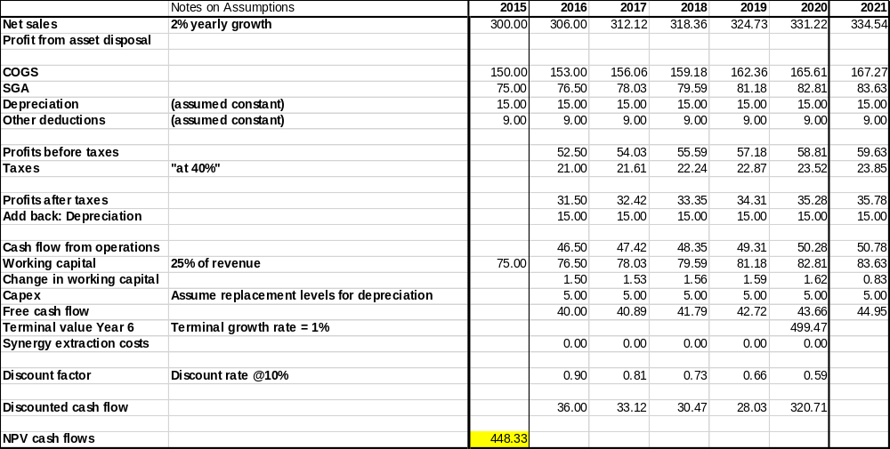
Table 5: Business A with synergies (in million dollars)
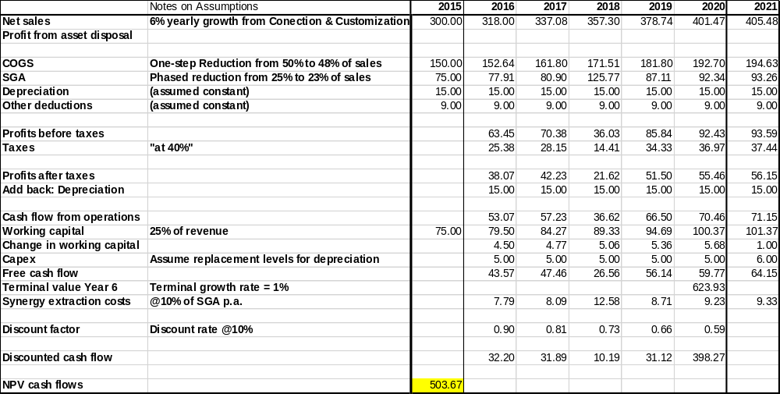
Table 6: Business B standalone (in million dollars)
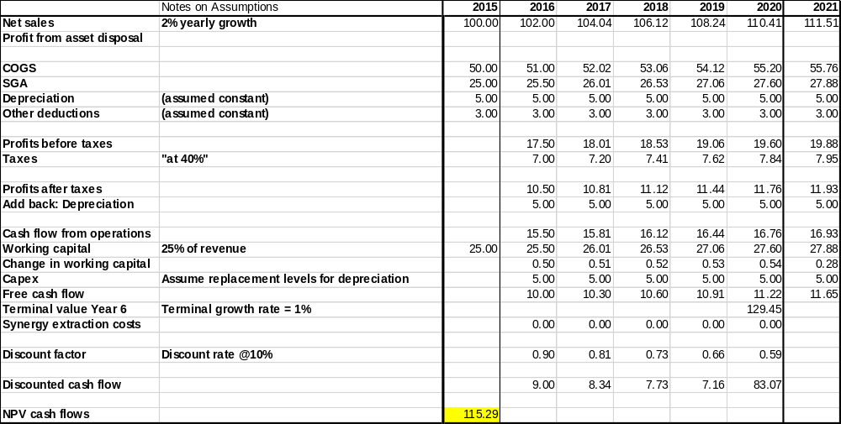
Table 7: Business B with synergies (in millions dollars)
